CLIENT NUMBER:

Madame, Monsieur,
You are now a Gazifère customer! Thank you for having chosen an energy source like no other, synonymous with comfort and energy efficiency. We are writing to ask you to please validate the information we have on file to ensure the accuracy of our records.

If you are the owner of this address, and it is being rented by someone:
- Please notify your tenant that he or she should contact us as soon as possible to complete the transfer of respon- sibility. We will not be able to make any changes without your tenant’s consent.
If you are the resident owner of this address or the resident tenant at this address:
- To complete your file, please notify us of any incorrect or missing information and your corrections by calling our Customer Portal at 819-771-8321, or by writing to info@gazifere.com

Do you have questions about your bill?
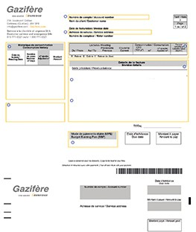
Account number, consumption history and determination, status of your account... understand your bill at a glance using our example :



Click below to access a form you will need to fill out (it will only take a few minutes):

WELCOME
TO GAZIFÈRE!

Welcome to Gazifère - Gazifère (gazifere.com)
According to our terms of service, the contract between you and Gazifère comes into effect once your natural gas service application is approved. Even though the contract is not in writ- ing, it remains in effect until it is terminated by the customer or Gazifère.

Manage your consumption and your bills from your Customer Portal!
Your Customer Portal, accessible through www.gazifere.com, lets you check your bill, your transaction history, your current charges and your payment arrangements!

Did you know?
You can spread the total cost of your annual natural gas consumption across 12 monthly bills. Your monthly
payments are reviewd twice a year, in March/April and in September, to align with your consumption and the price of natural gas. Are you interested ?
All it takes is a few clicks : it’s simple and quick! My bill - Gazifère (gazifere.com)

Gazifère proposes different payment methods. Choose the one that best suits you!
- Pay your bill online through your banking institution.
- Sign up for the automatic withdrawals program: it’s simple and quick! Recommended.

Adhere to gas from renewable sources
Since 2020, we have been offering our customers the option of contributing to a better environment by opting into the RSG rate. Customers who voluntarily agree to have part of their consumption billed at the RSG rate encourage the RSG program and help reduce GHG and methane emissions.


A few tips and tricks
to optimize your consumption
- Be in control with a smart thermostat. As your ally in your energy saving efforts, it adapts to yours habits preferenc- es. You can control it remotely through you smartphone, as it responds to the temperature fluctuations in your home and integrates your routine. If you are eligible, when your purchase and install a smart thermostat, you will receive

$100.
- Make the most of natural light: open your curtains on sunny days.
- Change your furnace filter! A clean filter helps deliver optimal performance. Change it every three months to maintain your system.
- Set your ceiling fan direction clockwise in winter to run your heating efficiently, and counter-clockwise in the summer to pull the hot air up. A simple trick to improve air circulation!
- Keep furnace intake and exhaust pipes clear of obstructions (*if you have a forced air system).
As a rule, well-maintained appliances enable you to optimize your consumption ! You’ll find all our tips at :
Optimize your consumption - Gazifère (gazifere.com)




SERVICES AND OFFERS

Some examples:

Did you know?
Gazifère offers you the chance to obtain cash incentive when you purchase and install an energy
efficiency appliance!
As a residential customer, you may be eligible for $400 when you install an air exchanger with heat recovery, $500 for a condensing tankless water heater or $850 for a high efficiency combined heating system (conditions apply).
FIND OUT ABOUT THE CASH INCENTIVES FOR RESIDENTIALS

Your furnace and water heater are rented, these are your benefits:
- No up-front cost for a standard installation (subject to the stipulations set out in the rental contract)
- 24/7 repair service
- Maintenance and repair costs fully covered
- Safe installations compliant with government standards

Safety is everyone’s business, and a priority at Gazifère
To ensure your safety and that of your family, have your equipment maintained by a certified natural gas professional. Have your air ducts and gas exhaust checked at the same time.
Keep the area around your combustion equipment clean. Do not obstruct the display, air intake or exhaust.
Gazifère encourages its customers to check the batteries for their alarms when setting the clock back or forward!
Safety and Prevention - Gazifère (gazifere.com)




SERVICES AND OFFERS

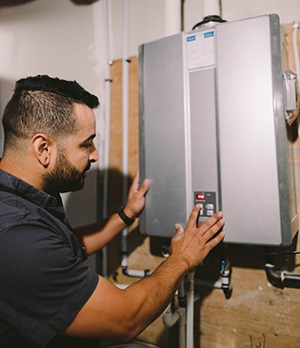
Are you going to be away for a while?

Did you know?
Your meter must at all times be visible, and must never be covered by a tarp or any sort of structure. In the interest of safety, clear away any snow buildup.
If your meter is covered in ice, contact our Customer
Portal as soon as possible.
If you’re going to be away for a short while (less than two weeks), Gazifère recommends you lower the thermostat setting by 2 or 3 degrees.
Several appliances can be adapted while you’re away to optimize your heating or air conditioning. That’s the case, for instance, with standard natural gas water heater (connected to a chimney), which can be set a “vacation” mode. Power vent water heaters can simply be disconnected while you are away, and for additional safety, shut off the cold water supply to limit the risk of damage from leakage. For electric water heaters, switch off the power supply as well as the cold water supply. Save energy!
For additional tips and tricks : A few suggestions before you go on vacation - Gazifère (gazifere.com)

